web programming  
LAB 8

23BCE1016 Tarun Chebolu

## Question-1

## Question -2

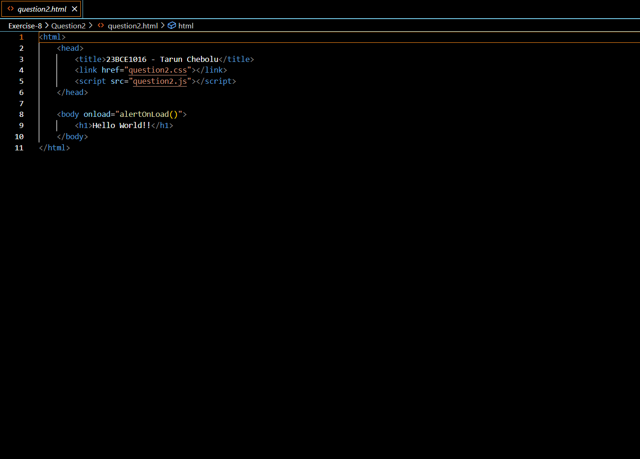

## Question -3

Output

If we click yes

If we click no

## Question -4

## OutputA screenshot of a computer AI-generated content may be incorrect.A screenshot of a computer AI-generated content may be incorrect.A screenshot of a computer AI-generated content may be incorrect.A screenshot of a computer AI-generated content may be incorrect.Question -5A screenshot of a computer AI-generated content may be incorrect.A screenshot of a computer AI-generated content may be incorrect.

## Question -6

